Stat 103 Homework Three Spring 2016

Instructions: The due date is Monday, 3-7-2016.

- When asked about the model used in simple linear regression, a student responds: 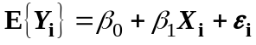. What was the student's mistake?
- In a study of the relationship between physical activity and the frequency of cold for senior citizens, participants were asked to record their time spent exercising over a 5-year period. The study demonstrated a negative linear relationship between time spent exercising and the frequency of colds. The researchers claimed that increasing the time spent in exercise is an effective strategy for reducing the frequency of colds for senior citizens. What mistake has the researcher committed?
- When asked the importance to simple linear regression model of assuming that the distribution of the error variable is normal, a student responds "for the least squares to be valid, the distribution of must be normal." What was the student's mistake?
- A special case of the simple linear regression model is the model given by 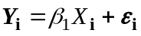, which corresponds to fitting a regression line through the origin. (We may have reasons for believing this is appropriate.) Using calculus, find the least squares estimator of 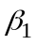. (Hint: you don't need to take partial derivatives here because there is only one independent variable.)
- A special case of the simple linear regression model might be given by 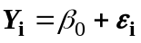, which corresponds to fitting a regression line with zero slope. (We would never do such a thing in practice of course.) Using calculus, and the hint in problem 4, find the least squares estimator of 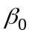. Comment on the result.
- Prove that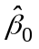, the least squares estimator of in the simple linear regression model 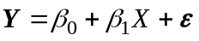, is unbiased.
- In fitting the simple linear regression model, it was found that the i^{th} observation fell exactly on the line. Would removing the observation from the data affect the least squares line fitted to the remaining n - 1 observations? Explain.
- A simple linear regression model for sales versus advertising expenditures for a product returns the following output
- Estimated regression equation: 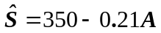
- Two-sided P-value for estimated slope = 0.91
What is wrong with the conclusion, "The more spent on advertising, the fewer units are sold."
- A value of the coefficient of determination, R², near 1 is sometimes interpreted to imply that the linear regression line can be used to make precise predictions about Y given knowledge of X. Is this interpretation a necessary consequence of the definition of R²? Explain.
- Suppose that the assumption of the simple linear regression model that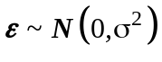 is violated in the following way: the variance is greater for larger X.
- Does 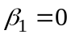still imply that there is no linear association between X and Y? Explain.
- Does still imply that there is no association (of any kind) between X and Y? Explain.
- Five observations on Y were obtained corresponding to X = 1, 4, 10, 11, and 14. Assuming that 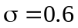, 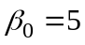, and 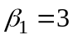, what are the expected values of MSE and MSR?

